**Name:** Walid Sultan Aly Ahmed

**R-1.1**

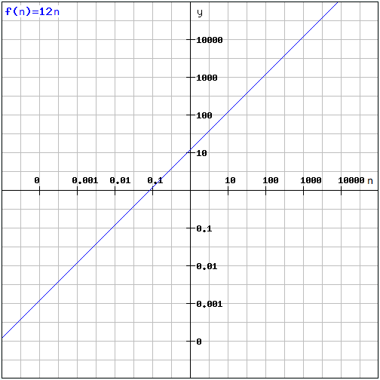 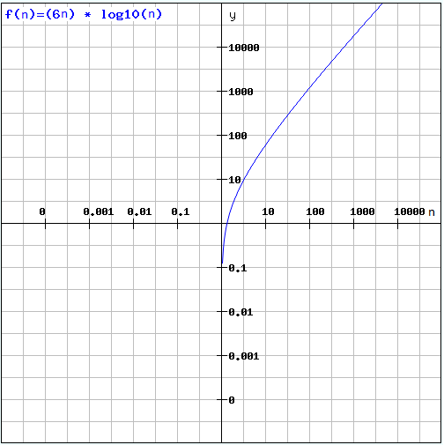

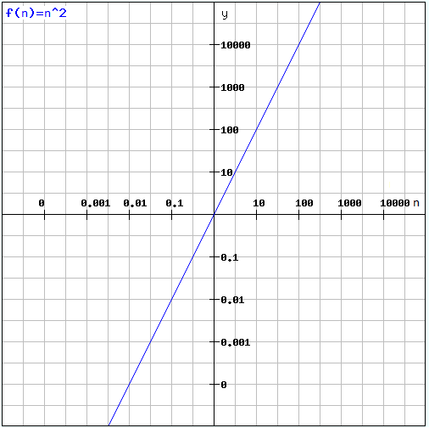 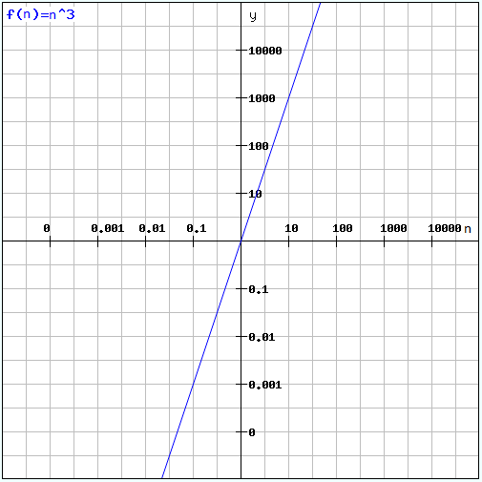

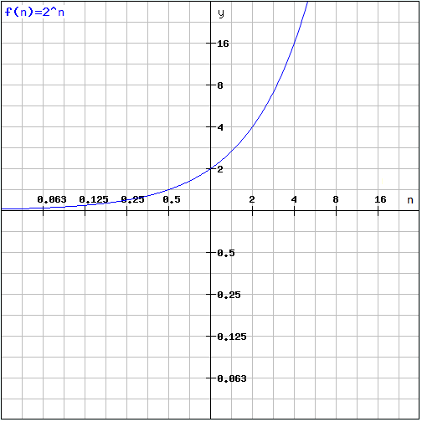

**R-1.2**

10*n* log *n <= n2*

10 log *n <= n*

*no* = 10

**R-1.6**

4n

2n

n3

n2 log n

4log n

2n log2 n

4n3/2

n log n

5n

n1/2

log log n

1/n

**R-1.10**

**Algorithm** Loop1(n)

s ← 0 1

**for** *i* ← 1 **to** *n* **do** n

*s* ← *s* + *i* n

**Algorithm** Loop1 runs in O(n) time

**R-1.14**

**Algorithm** Loop5(n)

s ← 0 1

**for** *i* ← 1 **to** *n*2 **do** n2

**for** *j* ← 1 **to** i **do** n2 (n2+1)/2

*s* ← *s* + *i* n2 (n2+1)/2

**Algorithm** Loop5 runs in O(n4) time

**Proof**

Logb xa = a logb x

let Logb xa = y

by = xa

by/a = x

logb by/a = logb x

y/a = logb x

y = a logb x